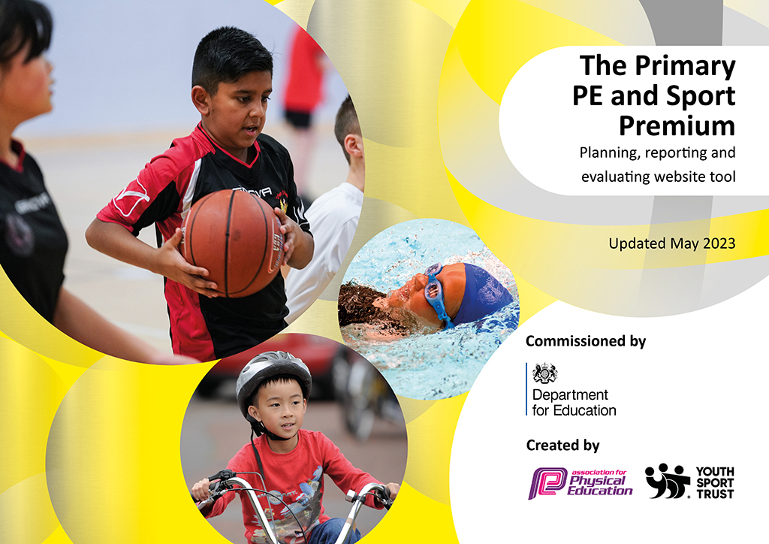
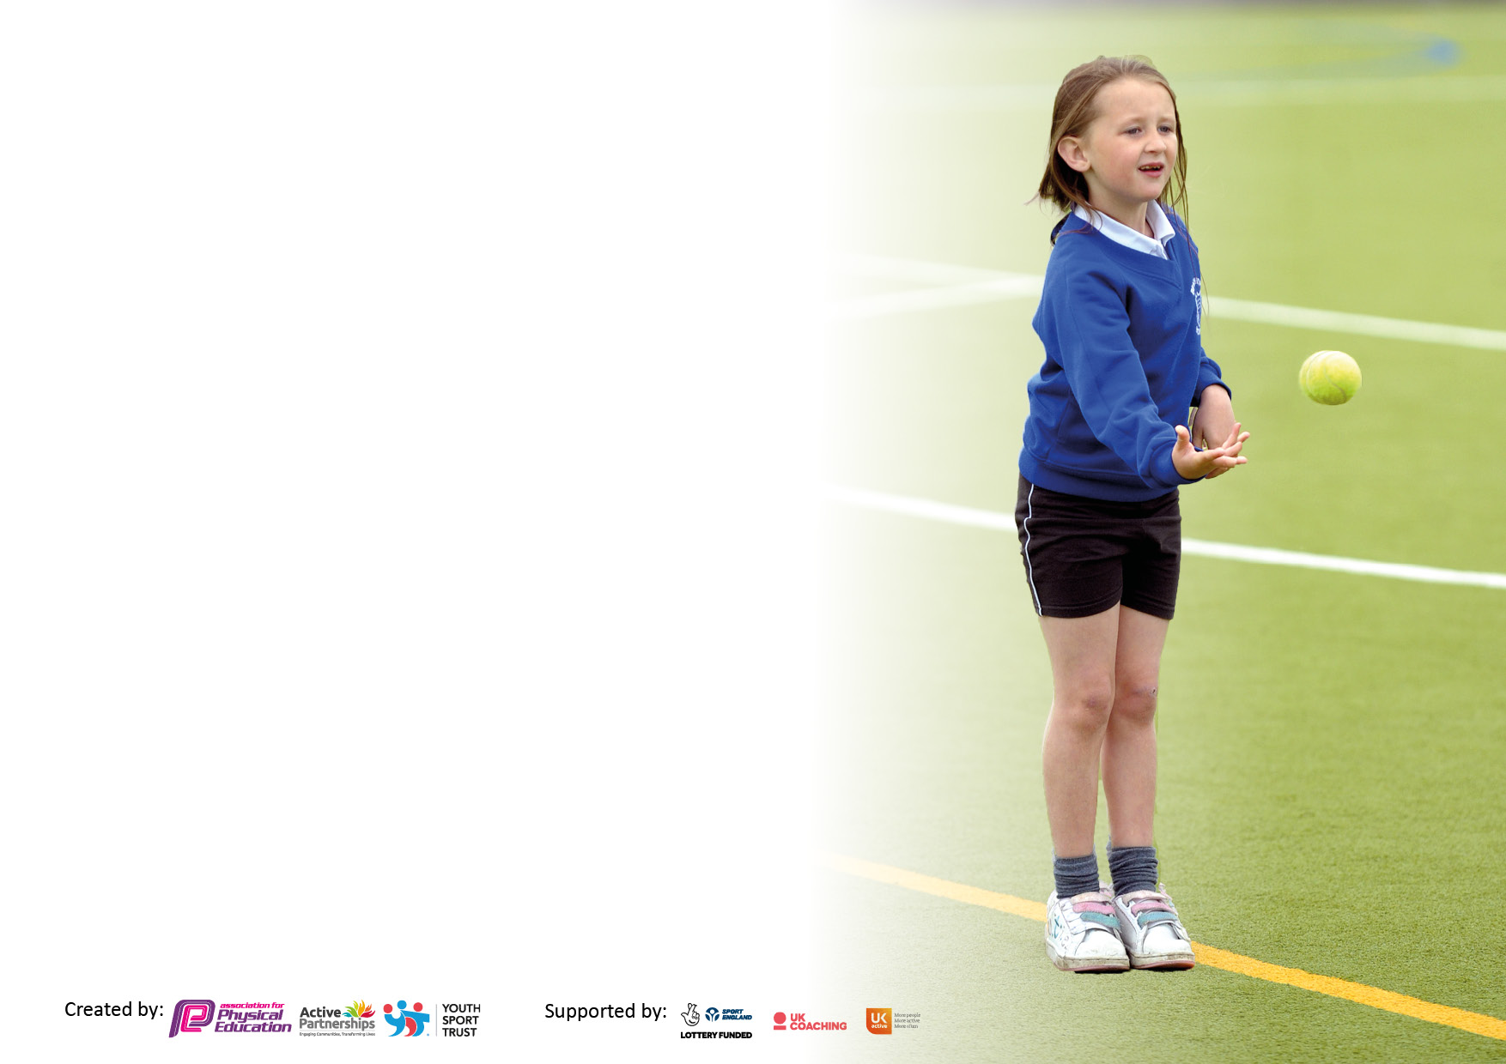

It is important that your grant is used effectively and based on school need. The Education Inspection Framework makes clear there will be a focus on ‘whether leaders and those responsible for governors all understand their respective roles and perform these in a way that enhances the effectiveness of the school’.

Under the Quality of Education Ofsted inspectors consider:
Intent - Curriculum design, coverage and appropriateness
Implementation - Curriculum delivery, Teaching (pedagogy) and Assessment
Impact - Attainment and progress

To assist schools with common transferable language this template has been developed to utilise the same three headings which should make your plans easily transferable between working documents.

Schools must use the funding to make additional and sustainable improvements to the quality of Physical Education, School Sport and Physical Activity (PESSPA) they offer. This means that you should use the Primary PE and sport premium to:

- Develop or add to the PESSPA activities that your school already offer
- Build capacity and capability within the school to ensure that improvements made now will benefit pupils joining the school in future years
- The Primary PE and sport premium should not be used to fund capital spend projects; the school’s budget should fund these.

Please visit gov.uk for the revised DfE guidance including the5keyindicatorsacrosswhichschoolsshoulddemonstrate an improvement. This document will helpyoutoreviewyourprovisionandtoreportyourspend.DfEencouragesschools to use this template as an effective way of meeting the reporting requirements of the Primary PE and Sport Premium.

We recommend you start by reflecting on the impact of current provision and reviewing the previous spend.

Schools are required to publish details of how they spend this funding, including any under-spend from 2021/2022, as well as on the impact it has on pupils’ PE and sport participation and attainment. The funding should be spent by 31st July but the DfE has stated that there will be no clawback of any unspent money so this can be carried forward into 2023/24.

We recommend regularly updating the table and publishing it on your website throughout the year. This evidences your ongoing self-evaluation of how you are using the funding to secure maximum, sustainable impact. Final copy must be posted on your website by the end of the academic year and no later than the 31st July 2023. To see an example of how to complete the table please click HERE.

Details with regard to funding
Please complete the table below.

Total amount carried over from 2021/22 | £8106.81 for accrued purchases
Total amount allocated for 2021/22 | £30,083 including carry-over from 20/21
How much (if any) do you intend to carry over from this total fund into 2022/23? | £984.25
Total amount allocated for 2022/23 | £19,100.00 PE premium, £8106 carried forward. £27,206 total.
Total amount of funding for 2022/23. Ideally should be spent and reported on by 31st July 2023. | £ £25,419.61 spent, £1765.39 carried forward into 23/24
Swimming Data
Please report on your Swimming Data below.

Meeting national curriculum requirements for swimming and water safety.

N.B. Complete this section to your best ability. For example you might have practised safe self-rescue techniques on dry land which you can then transfer to the pool when school swimming restarts.
Due to exceptional circumstances priority should be given to ensuring that pupils can perform safe self rescue even if they do not fully meet the first two requirements of the NC programme of study
What percentage of your current Year 6 cohort swim competently, confidently and proficiently over a distance of at least 25 metres?  N.B. Even though your pupils may swim in another year please report on their attainment on leaving primary school at the end of the summer term 2023.  Please see note above | 69%
What percentage of your current Year 6 cohort use a range of strokes effectively [for example, front crawl, backstroke and breaststroke]?  Please see note above | 64%
What percentage of your current Year 6 cohort perform safe self-rescue in different water-based situations? | 85%
Schools can choose to use the Primary PE and sport premium to provide additional provision for swimming but this must be for activity over and above the national curriculum requirements. Have you used it in this way? | Yes/No  Y6 Top up, £2,583

Action Plan and Budget Tracking
Capture your intended annual spend against the 5 key indicators. Clarify the success criteria and evidence of impact that you intend to measure to evaluate for pupils today and for the future.

Academic Year: 2022/23 | Total fund allocated:19,100 | Date Updated: 28/7/23
Key indicator 1: The engagement of all pupils in regular physical activity – Chief Medical Officers guidelines recommend that primary school pupils undertake at least 30 minutes of physical activity a day in school |  |  |  | Percentage of total allocation:
 |  |  |  | 10%
Intent | Implementation |  | Impact
Your school focus should be clear what you want the pupils to know and be able to do and about  what they need to learn and to  consolidate through practice: | Make sure your actions to achieve are linked to your intentions: | Funding allocated: | Evidence of impact: what do pupils now know and what can they now do? What has changed? | Sustainability and suggested next steps:
INTENT- We aim to provide 30 minutes of physical activity every day for all pupils, by providing time in the curriculum for daily mile runs and opportunities to be active at every playtime and lunchtime. The children have access to equipment during these sessions including the outdoor learning opportunities, equipment including high quality skipping ropes, elastics (and skipping workshops), access to football, basketball and netball games, table tennis tables, along with playground markings for hop scotch, daily mile track and dance, fitness and outdoor learning opportunities.
Active breaktimes provided for with a large amount of resources. | Equipment to promote 30 minutes of activity daily | £539.95 | The children have access to fitness equipment each playtime and lunchtime. Basketball, netball, table tennis, football, space hoppers, throwing and catching | Equipment will need replacing as wear and tear and a high percentage of the children accessing the equipment means that some equipment is damaged.
Storage boxes to provide quick and easy access to equipment used by sports leaders when running activities for children at playtime and lunchtimes. | 3 Large metal boxes replaced the plastic ones. These are more durable and larger, allowing equipment to be better stored and therefore last longer. | £1,980 | Children need easy access to the equipment. The boxes need to be waterproof and able to withstand 400+ children accessing equipment. Old plastic ones were not durable- these have stood up to heavy usage. | Ongoing resource- should last one more year at least before replacing.
Playleaders have been trained up in leading activities  They help to support lunchtime and playtime fitness and support at Sports days and other sporting events. | Football equipment, bespoke bibs, referee whistle.  Sports days- multiple pieces of equipment. | New football goals included in costs above. | Playleaders work with all the children, especially successfully across KS2, taking responsibility for refereeing football and managing other activities.  Sports Leaders trained and led the entirety of LKS2/UKS2 sports days and successfully helped KS1 and FDN Sports Days too. | Next year’s sports-leaders will be trained up in AUT1 and will be able to reuse the equipment.  Aim is to acquire Sports Leaders’ Caps/tabards (unavailable this year) and have them raise their profile across KS1 when breaktimes coincide.
All classes run the daily mile. | School wide expectation that each class conducts the Daily Mile. | £0 | Running assessments conducted by Martin Tilling and Adele Winfield at start and at end of academic year to show progress in fitness. | This will continue without any additional budget being required, unless track needs replacing/repainting.
Key indicator 2: The profile of PESSPA being raised across the school as a tool for whole school improvement |  |  |  | Percentage of total allocation:
 |  |  |  | 9%
Intent | Implementation |  | Impact
Your school focus should be clear what you want the pupils to know and be able to do and about  what they need to learn and to  consolidate through practice: | Make sure your actions to achieve are linked to your intentions: | Funding allocated: | Evidence of impact: what do pupils now know and what can they now do? What has changed?: | Sustainability and suggested next steps:
Physical Education, School Sport and Physical Activity (PESSPA)

The school website has a special section allocated to the PE and Sports funding which reports to parents and the community the ways we are promoting sport, fitness and mental well-being across the school. The use of the PE Premium is usually reported to governors on an annual report explaining how the fund is being spent and the opportunities we are offering the pupils and staff. All school sports events reported on in staff/governor newsletter.
Issues relating to poor gross and fine motor skills had been identified by staff, post pandemic, previous year.  This had had a huge impact on cutting, writing and basic pencil control. Research has also shown that the youngest children, had suffered the most, as their development of these skills has been halted during Covid, with many children missing out on stages of development.  The FS had been struggling to address this and had requested a range of equipment to meet these needs and a plan of Multi-Skills teaching devised for KS1. | We have ordered a large range of equipment specifically for EYFS so that we can close this gap, allowing the children to keep up.  This includes multi-sensory and emotion balls, climbing and crawling equipment, balance boards, stepping-stones and dance equipment. | £332.97 of funding used for school-wide multi skills equipment, plus :  £1522.87 spent on ABC equipment for Foundation | Children use the equipment in curriculum time, especially in coaching sessions with external providers. (MT-FDN, JA-Y1-3) Equipment also used by foundation in guided play.  Josh measured multi-skills baselines in Y1 and saw such increases as: 289% (almost a threefold improvement) increase in bean bag throw accuracy over 3 months and 30% increase in catching accuracy in the same time period. | Ongoing assessment will track the development of these skills and Josh/Martin will continue Multi-skills with children lower down school to develop further their gross and fine motor skills.
Use outside providers as sporting role models for children. | Sports events led and coached by local sports teams/coaches.  (Nottingham Women’s rugby team coached Y4 tag rugby. Nottingham Hockey club, Men’s and Women’s coached Y6 Unihoc festival) | All time provided free of charge by University Volunteers and outreach.  Set of rugby balls, £185.98 | Link to Nottingham University established and volunteers provided by the Outreach and Sporting Opportunities Officer. | Expand the range of sports or activities next year- including possible visits for the children to University facilities.
To raise the profile of fitness and wellbeing through assemblies. | Wellbeing and sports assemblies are scheduled for each half term and delivered across KS1 and KS2. | No cost. | Wellbeing and physical health are integral features of the PSHE syllabus covered by all staff. | Ongoing. Aim for 2023-24 to invite sporting guest speakers/local clubs into assemblies; sports clubs invited to Sports Week in June 2024 via SGO.

Key indicator 3: Increased confidence, knowledge and skills of all staff in teaching PE and sport |  |  |  | Percentage of total allocation:
 |  |  |  | 69% (includes KI 4 costs also)
Intent | Implementation |  | Impact
Your school focus should be clear | Make sure your actions to | Funding | Evidence of impact: what do | Sustainability and suggested
what you want the pupils to know | achieve are linked to your | allocated: | pupils now know and what | next steps:
and be able to do and about | intentions: |  | can they now do? What has
what they need to learn and to |  |  | changed?:
consolidate through practice:
INTENT-To provide top quality access to sessions with professional coaches both during curriculum time and after school club opportunities. This will benefit both the staff through CPD and pupils due to variety of extra opportunities and increased range of sports offered. (This year, handball, fencing, multi-skills all newly introduced) Session plans made available for staff to use for own CPD afterwards.
To employ external and additional expert staff to run curriculum sessions side by side with staff members both as CPD opportunities and to provide opportunities for the children to develop their skills in areas identified as a weakness by staff- especially the multi-skills approach in lower school. | Fundamental ABC (Agility, Balance, Coordination) skills had been identified as a weakness in FS due to children missing out on the development of these skills during the COVID lockdown. Bespoke sessions with Josh (FDN, Y1, Y2, Y3) and Martin (Y4) pitched at targeting gross and fine motor skills. | £15,655  (See breakdown in box below) | Josh obtained baseline- exit data for the children he worked with. They have noticed a marked improvement in gross motor skills especially throwing, catching and targeting skills, suggesting a considerable increase and improvement in their motor skills.  Session plans made available for staff to use for own CPD afterwards. | Continue to develop these skills going forwards and expand into other sports such as gymnastics for gross motor control.
Continued CPD for staff including TAs in gymnastics, cricket and badminton, plus multi-skills and handball. | Cricket (Joe Ashdown Academy)  Gymnastics/multi-skills/  handball/fencing ASC (Premium Education)  Badminton/table tennis/multi-skills (Zenith) | £4754.99  £5205  £5730 | All these children have received professional coaching from an outside specialist and staff accompany sessions gaining CPD.  YR6/Y2/Y5 Curriculum Cricket  Y1/Y3/Y2/FDN Gymnastics and Multi Skills Curriculum sessions  Y4/Y1/FDN/Y3 Curriculum sessions with MT | Staff have accompanied specialist coaches during all these sessions and gained valuable CPD.  Next year, the aim is to revisit PITA to improve our assessment of a child’s physical progress and ability in the range of sports offered.
iMoves platform provides curriculum planning for all staff to use to ensure that sessions are well planned and that there is progression and assessments are available for staff to track the development of the children throughout their school life. | Staff use the planning and assessments to inform their judgements and pass this information onto the next teacher | £847.06 | Staff access good quality planning and resources, along with PITA (Place in time assessments) sheets to track the children’s development | Resources have already been used in previous years and much planning can be reused. Assessments are embedded into the half termly planning cycle (AW conducted In 2022-23)  Training will be given in Autumn 2023 to all staff as a refresher and first time to new members of staff, especially PITA.
Access to good quality PE equipment in curriculum time.  Staff have access to whole class sets of appropriately sized footballs, netballs, basketballs, handballs and rugby balls in bags for easy access.  Rounders set replacing old kit  Equipment includes distinct football and handball goals, targets, rebounders, needles, stop watches, , tape measures, marker cones; dance equipment | Class sets of balls and equipment have been purchased to replace worn and flat balls. These are stored in the PE store and are easily accessible to the children.  Rounders class set  Aluminium Handball goals and quickplay indoor goals  Maypole dance kit; parachute; whole class dance kit  Athletics equipment- javelins, quoits, markers, stopwatches and measuring tapes | £953.92 new balls  £105  £386.50/ £186  £268.98  £414.99 | Increased engagement from pupils as resources replaced and improved. More resources per child now available. | Maintain equipment and ensure adequate storage is available for new resources.  (Site manager constructing extra storage over summer holiday, enabling all equipment to be stored adequately)
Key indicator 4: Broader experience of a range of sports and activities offered to all pupils |  |  |  | Percentage of total allocation:
 |  |  |  | 11% + ASC costs included in KI3 above
Intent | Implementation |  | Impact
Your school focus should be clear | Make sure your actions to | Funding | Evidence of impact: what do | Sustainability and suggested
what you want the pupils to know | achieve are linked to your | allocated: | pupils now know and what | next steps:
and be able to do and about | intentions: |  | can they now do? What has
what they need to learn and to |  |  | changed?
consolidate through practice:
INTENT-The school focus is to provide a wide range of activities and experiences for the children, above and beyond the curriculum offer. We intend that every child leaving John Clifford will be able to complete the JC triathlon in that they will be able to swim 25m, run a mile and be able to ride a bike safely (on the road). This year has all been about re-establishing links, networks and contacts with other PE and sports bodies in the area. Through this, a plan of action came about to develop a series of inclusive, sports festivals (named South Broxtowe Sports Festivals) which have already begun and to appoint and develop a new School Games Organiser role. This has occurred and we have worked together to provide wider opportunities.

Increased range of sports being implemented:  Archery being taught in Y6  Badminton after school club Y4/5  Fencing after school club Y6  Gymnastics after school club Y1/ Y2/3  Handball after school club Y3/4  Dance festival Y1/2  Unihoc festival UKS2  Basketball festival UKS2  Sports days run by trained Sports Leaders from Y6 and Y5 | Provide a range of opportunities for the children throughout the school year. | (After school clubs included in KI3 costs above)  Festivals run by staff- supply covered in house with no extra funding required. | All YR6 children had an opportunity to have a go at archery as part of regular PE sessions.  YR5/6 after school badminton club  YR3/4 Handball and Dodgeball Club  YR4 ASC Tag Rugby, Olympic Athletics, Badminton  YR1/2 children accessed dance practices at lunchtime and performed at the Family of Schools Dance Festival | These activities will continue in 2023-24 as the range of South Broxtowe Festivals increases.  Will look to expand further the range of clubs on offer in 2023-24 and strengthen links with local clubs such as Nottingham Casuals and the Croquet club. South Broxtowe Sports Festivals will also take place using these skills.
YR6 Top up swimming curriculum to ensure that all children have the additional opportunity (we offered 4 terms of swimming lessons in YR4 & 5 | Children attend top-up swimming sessions at the Olympic sized pool at the Harvey Haddon sports Village (6 weeks SUM2) | £2,583 | See % of children achieving the National curriculum requirements for swimming and water safety. | If possible, continue this support for YR6 pupils as due to many different reasons many of our children do not access swimming at home.
Bike ability opportunities in YR5  After initial assessment, children able to access bike sessions during the school day to enable them to ride safely- L1 assesses basic competence, L2 takes the children out onto local roads and cycle paths. Some use our supply of 15 bikes and helmets. | All YR5 children take part in the Bike Ability scheme in SPR1. | No cost directly to school. Cover for staffing provided in-house. | 91% of children who are able to ride a bike at the end of YR5  42 children completed Level 1  41 children completed Level 2  School provided bikes for those children who did not have access to them. | Develop this further in 2023-24. Plan in place with First Grade Sports to try and ‘top-up- any Y6 children who still cannot safely and confidently ride and hopefully assess Y4s on Level 1 Bikeability too, subject to availability.
Year 6 took part in an activities based residential to Willersley Castle in Derbyshire. This was a physical activities led visit. | Children took part in a wide range of physical activities | N/A | 40 children from the cohort took part in the visit. Activities included: rock climbing, grass sledging, rifle shooting, axe throwing, orienteering, trampolining and fencing. | Continue this residential in future years. As a direct result of the residential, we then asked Premier Education to lead a fencing club after school, which was well patronised and now a new feature of our ASC offer.
Badminton provision. This is a sport now in its 2nd year at JC. Full set of equipment bought with last year’s funding. | Sessions have been run across KS2 for children in after school provision.  A full set of nets and racquets were purchased to allow whole class teaching. | Staffing costs factored into KI3 above | Year 4 and Year 5 After school clubs continued this year using the full set of equipment purchased with accrued funds from last year’s budget. | Equipment and training means that badminton can be confidently taught in school and will become part of the ‘Sports Academy’ offer going forwards and may feature as a South Broxtowe Sports Festival sport in 2023-24.
Extra hockey provision has been introduced as the children identified via SGO and South Broxtowe questionnaire, Autumn 2022. | Full class set of Unihoc equipment purchased from last budget and Unihoc festival introduced. | No cost, supply for festival covered in-house. | 8 children attended a inter-school trial festival, supported by SGO and Nottingham University Hockey players, mens and womens. | Equipment is available going forward for curriculum teaching and further inter-school competitions will take place as part of a new sports calendar being developed.
Indoor and outdoor table tennis provision | Indoor and outdoor tables were purchased in previous years, new equipment was needed to replace old and broken equipment. | £71.98 | Children have access to table tennis at playtime and lunchtime. | Ongoing
Handball equipment | Handball goals purchased using funds accrued in previous year. Handball introduced by Josh and Adele in various year groups and ASC. | £572 | Children have developed new skills in handball in both curriculum and ASC. | This will lead onto South Broxtowe Sports Handball Festival in 2023-24 (October)

Key indicator 5: Increased participation in competitive sport |  |  |  | Percentage of total allocation:
 |  |  |  | 0%
Intent | Implementation |  | Impact
Your school focus should be clear | Make sure your actions to | Funding | Evidence of impact: what do | Sustainability and suggested
what you want the pupils to know | achieve are linked to your | allocated: | pupils now know and what | next steps:
and be able to do and about | intentions: |  | can they now do? What has
what they need to learn and to |  |  | changed?:
consolidate through practice:
INTENT-After several years of missed competitive sport due to COVID restrictions, this year was the year to re-establish competitive sports in school and develop them across the local area. Via the South Broxtowe Sports Association, we were able to develop a) a fixture list of regular competitive football and netball matches and b) re-instate the end of year tournament. In addition, helping appoint and develop a School Games Organiser, we have been able to devise festivals of sport within the group, taking wider, more inclusive groups of children across the range of abilities to local festivals to compete against local schools. After a trial Unihoc festival, a basketball festival took place. Next year, multiple other sports will be introduced and the range and scope of this will continue to grow to include all year groups taking part.
To provide opportunities to allow children to participate in competitive sports (1) | Release staff to coach the netball team and provide a coach to train the cross-country runners.  DG chaired South Broxtowe Sports Association outside school hours, to create fixtures and tournaments. | No additional cost as covered on-house (netball) and as part of Sports Academy cross country Y6 (MT) ,covered above. | Netball team have played in three tournaments, finishing runners up in the SBSA.  Football team played full range of league matches and the 16 school, inter-school tournament.  Cricket tournament at Trent College.  (Y5) | The tournament was reintroduced for the first time in 4 years, providing outlets for competitive football and netball.
To provide opportunities to allow children to participate in competitive sports (2/) | Release staff to attend and lead sports festivals and tournament.  DG established South Broxtowe Sports Festivals, taking groups of children to Pearson Centre to represent school in inter-school competition.  Time created outside school hours, therefore no cost incurred. | No additional cost as cover provided- in house for festivals and tournaments. | Unihoc festival/ Basketball festival at Pearson Centre (Y6/Y5)  Dance festival- (Y1/Y2)  Cricket tournament- set up but PP until September (Y5) | South Broxtowe Sports Festivals are now a part of the local calendar. This will expand and develop next year, to fully represent the age range and the entire demographic of school, to allow everybody a chance to represent JC in competitive sport.

Signed off by
Head Teacher: | Janine Waring
Date: | 31.07.23
Subject Leader: | Dan Gooch
Date: | 31.07.23
Governor: | Simon Hogg
Date: | 31.07.23

